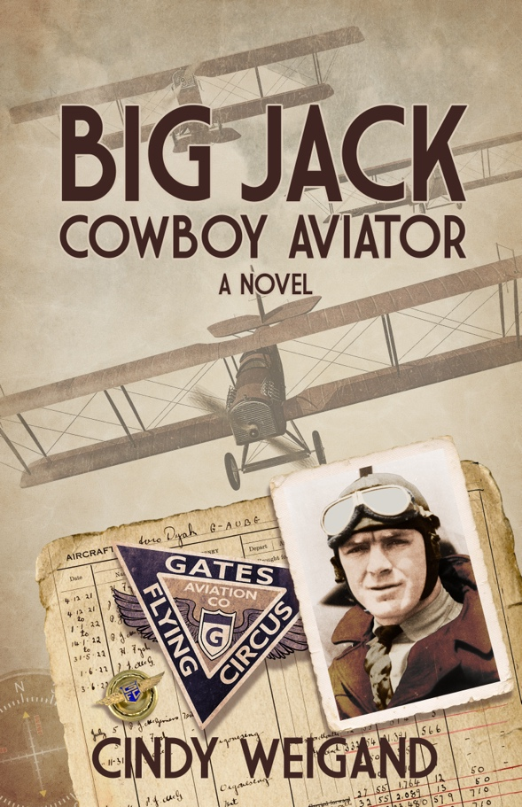
BIG JACK, COWBOY AVIATOR
CINDY WEIGAND

March 2024

398 Pages, historical fiction, available in paperback and eBook

ISBN: 979-8-9878848-5-0 (eBook)
ISBN: 979-8-9878848-6-7 (Paperback)

Cindy Weigand
CindyWeigand.com
info@cindyweigand.com
512.818.0472

Table of Contents
BIG JACK, COWBOY AVIATOR 1
DESCRIPTION 2
PITCHES & SUMMARY 3
PRAISE FOR BIG JACK, COWBOY AVIATOR 4
ABOUT THE AUTHOR 5
BIG JACK, COWBOY AVIATOR Q & A 6

DESCRIPTION

Once he joins the Gates Flying Circus in 1925, Jack Ashcraft never looks back even though his parents want him to be closer to home. Billed as the Worlds’ Greatest Exhibition Aviators, the group flies throughout the South and East Coast performing before crowds of tens of thousands. Soon, he becomes their star performer. Newspapers bill him as “Big Jack,” Cowboy Aviator because he spent time in Texas in the army. At six feet four inches tall, he is big. He relishes the adoration of fans. Women flock to be near him and seek his company. Despite Prohibition, booze is readily accessible. He experiences events that are history in the making. He’s living high.

As if life couldn’t get any better, he meets Mavis, a New York socialite who is also a pilot. Jack and Mavis bond as friends because of their love of flying. He can share things with her that he can’t share with the guys in the rough and tumble life of a flying circus. They get together when their flight paths cross.

When tragedy strikes, Jack’s buddies have his back, but it is Mavis he trusts with the emotions he feels. He is conflicted. Jack must come to terms with his desire to return to the flying life he loves and the reality of the dangers of flying.

Big Jack, Cowboy Aviator, gives the reader insight into the inner workings of flying circuses in the 1920s, and an ace pilot who flies with them. These groups of aviators flew from town to town and city to city giving exhibitions. Spectators marveled at the sight of an airplane. Most had never seen an airplane much less flown in one. Afterwards, they sold rides to any brave enough to fly in one. Pilots were the rock stars of the day. Men and women alike got into the game. The Gates Flying Circus was arguably the best. They performed before millions of people across the United States and gave rides to hundreds of thousands.

Told by his great grandniece, Big Jack, Cowboy Aviator, recreates the flying life of John Wesley “Jack” Ashcraft, Jr. His story was revealed to her through numerous newspaper articles that he saved, family histories, and letters home. The story includes thirty family and vintage photos.

PITCHES & SUMMARY

Airplanes, pilots, women, and hootch.

When tragedy strikes, Jack struggles to come to terms with the dangerous reality of flying and his desire to return to the life he loves.

Jack is living the life of his dreams as a pilot with a renowned exhibition team, then tragedy strikes. Will he be able to return to the life of flying that he loves?

The year is 1925. Confident of his aerobatic skills and fueled by his determination to make a name for himself, Jack Ashcraft leaves a humdrum flying business to join the Gates Flying Circus, billed as the World’s Greatest Exhibition Aviators. As their star performer, he makes headlines in newspapers throughout the eastern United States. Along the way, he befriends pioneering aviators and free-thinking flappers, flies in a transcontinental air race, and leads a simulated air attack on New York City. But his chosen calling conflicts with his family’s desire for him to be closer to home. When tragedy strikes, Jack struggles to come to terms with the dangerous reality of flying and his desire to return to the life he loves.

FLY BOYS meets THE GREAT WALDO PEPPER meets THE GREATEST SHOWMAN.

PRAISE FOR BIG JACK, COWBOY AVIATOR

“Cindy Weigand beautifully weaves facts and fiction in the novel Big Jack Cowboy Aviator. Using a number of primary sources, Weigand returns readers to the Golden Age of Aviation and allows them to take flight with “Big Jack” Ashcraft. With the turn of each page, Weigand explores the triumphs and tragedies of Ashcraft’s life and documents the extreme hazards associated with early aviation.”
—JENNIFER BOWER, Author, North Carolina Aviatrix VIOLA GENTRY: The Flying Cashier

“Anytime men come together in high-risk endeavors, a shared but often unspoken understanding forms. Ms. Weigand pries loose these private words, thoughts, and emotions for others to see, and feel.”
—DON PETERSON, Eight-year member of the US Advanced World Aerobatic Team, competitor
in four

ABOUT THE AUTHOR

CINDY WEIGAND
Cindy Weigand grew up on the prairie of western Oklahoma listening to her grandmother’s stories and has loved stories ever since. She is the author of an anthology, Texas Women in World War II, The Republic of Texas Press, an imprint of Rowman & Littlefield Publishing Group, Inc., 2003. In 2023, she published a novella, Ride of Passage based on reminiscences of her childhood. BIG JACK, COWBOY AVIATOR, is a historical novel, but also biographical fiction in that it is based on the life of a great uncle who was a pilot in the 1920s.

Weigand is also a film enthusiast and founder of GTX Film which produces an annual film festival in Georgetown, Texas. She served as President and Executive Director until 2023. She now resides in Tulsa, OK.

BIG JACK, COWBOY AVIATOR Q & A

Where did you get the idea for the story?

Going through my mother’s belongings after her death in 1992, I came across two scrapbooks of old articles, a poster for an air meet, family histories, letters, and several photographs. The articles were about Jack Ashcraft, a great uncle who was an aviator in the 1920s. I remembered Mom mentioning him growing up, but I wasn’t interested at the time. I had no idea she had all this information. My adult curiosity engaged; I became engrossed in finding out all I could about this amazing relative.
From the articles, descriptions of him in books, and family histories, I pieced together a narrative for his life. I knew what he did and where, but how it all came down is conjecture on my part. The result is Big Jack, Cowboy Aviator.

Where did you get the photos?

While I found several photos, I thought there must be more somewhere. Jack had five brothers and five sisters. Upon returning from vacation one summer, there was a telephone message from a distant cousin, Allen Keller, on my answering machine. Allen is a descendent of Jack’s oldest sister, Lillian. He found my name from a photo I had posted on the internet. When I excitedly returned the call, Allen told me that he had found a family photograph album in a trunk in his grandparents’ basement in Greensburg, KS. This town was destroyed by an EF-5 tornado on May 4, 2007, but the album survived. Allen has graciously shared many of the photos to use in the book. I located more photos while visiting museums and university collections.
Allen also found other artifacts in the family home. The current owner had hoped a family member might come for the artifacts. The items included his pilot’s license signed by Orville Wright in 1929, and trophies.

How much of the story is true and how much is fiction?
Most of the events in this book regarding the life of Jack Ashcraft occurred, but dialogue and circumstances, and in a few instances chronology, are fictionalized for the sake of narrative. I also created fictional characters to tell his story.

The novel has news articles that seem real. Are they? What was your thinking about including these elements?

The news articles are real. Jack lived a very itinerate life, yet he took the time to cut out the articles and save them. This told me that they were important to him. He wanted his family and others to know what he did and accomplished in his life. Maybe he sensed that he was making history. He and the Gates Flying Circus made headline and front-page news wherever they went. I saw the articles as a journal of sorts. In the story, Jack reads some of them, so in essence he’s telling his story. The articles are real time accounts and give the story authenticity. From the hundreds available, I used those that I believe helped tell his story. Also, the journalism in the 1920s was quite colorful.
As I mentioned, Jack had five brothers and sisters, so I have relatives that I have not nor possibly will ever meet. They may not know about this amazing relative and not have access to the information that I had. Hopefully they will hear about the book and learn more about “Big Jack” Ashcraft, Cowboy Aviator.

Do you have similar stories planned or possible a series?

I have thought about it. Who or what would you like to know more about?

